Q) Using Covid-19 dataset, create a mapping to find out the total confirmed cases in Canada.

SOLUTION: -

Step 1: - Connect with the repository, then right click on ETE and create a folder (Folder Name: - Sumit_11703319).

Step 2: - Right click on folder and create a Data Object.

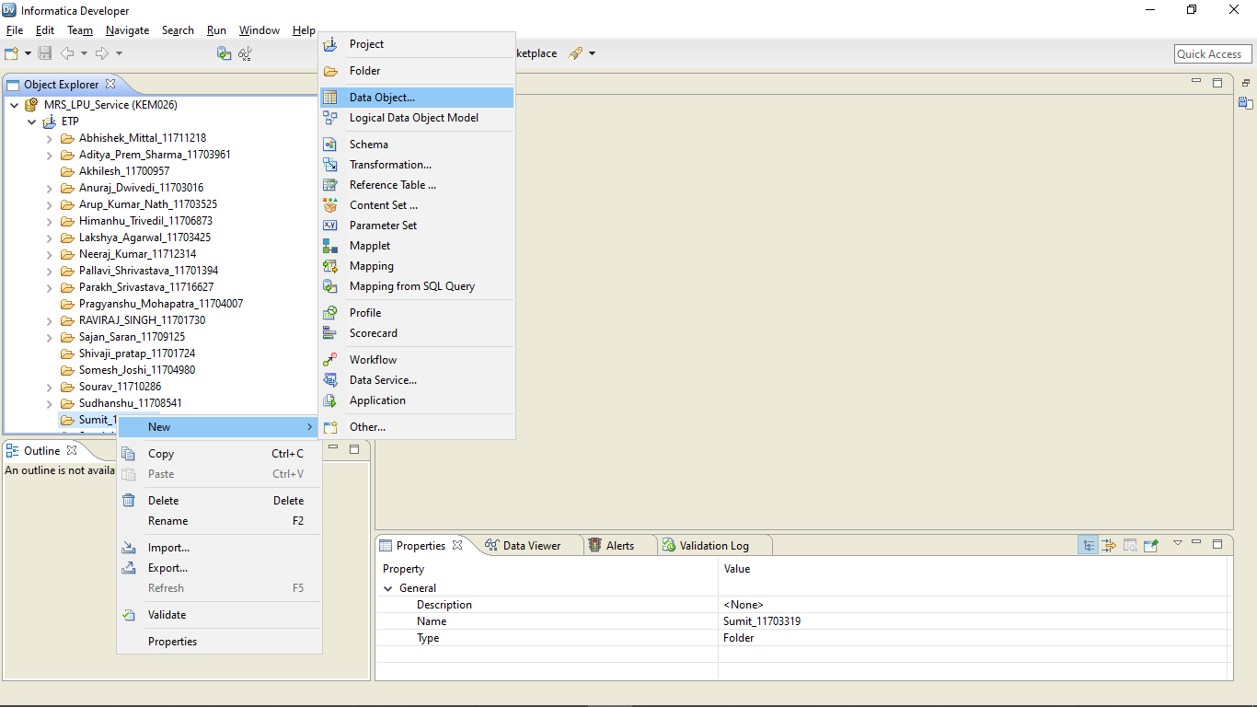

Step 3: - Select Flat file data object and import the Covid_19.csv file.

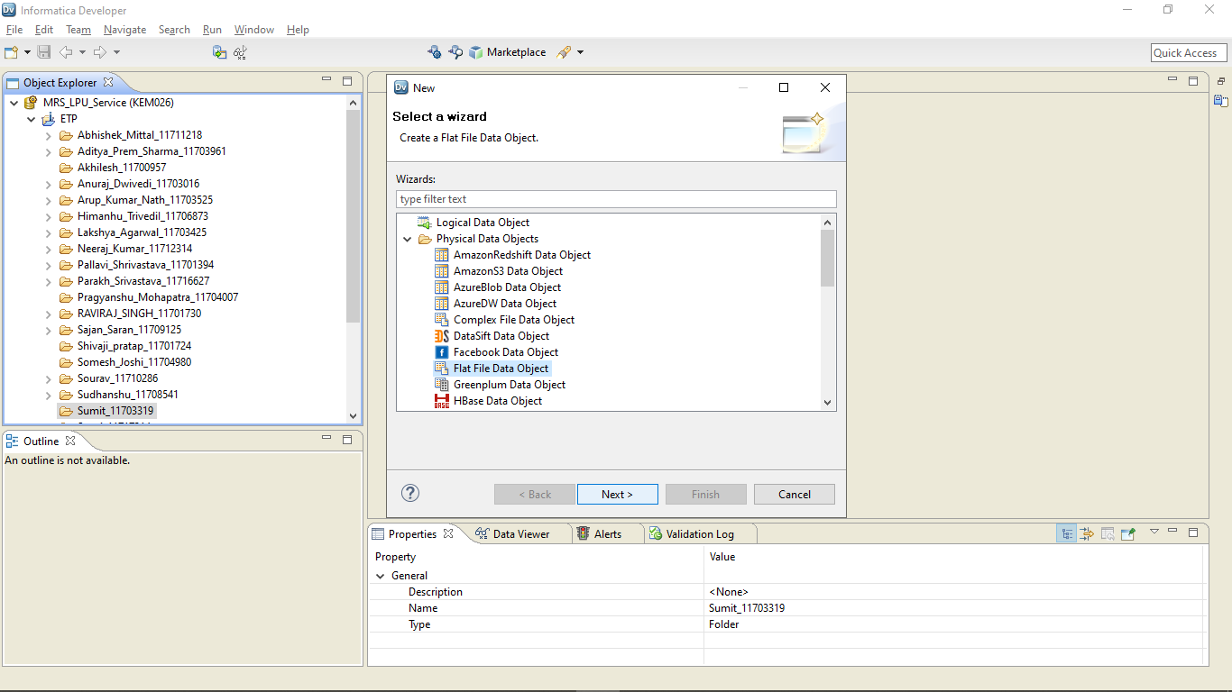

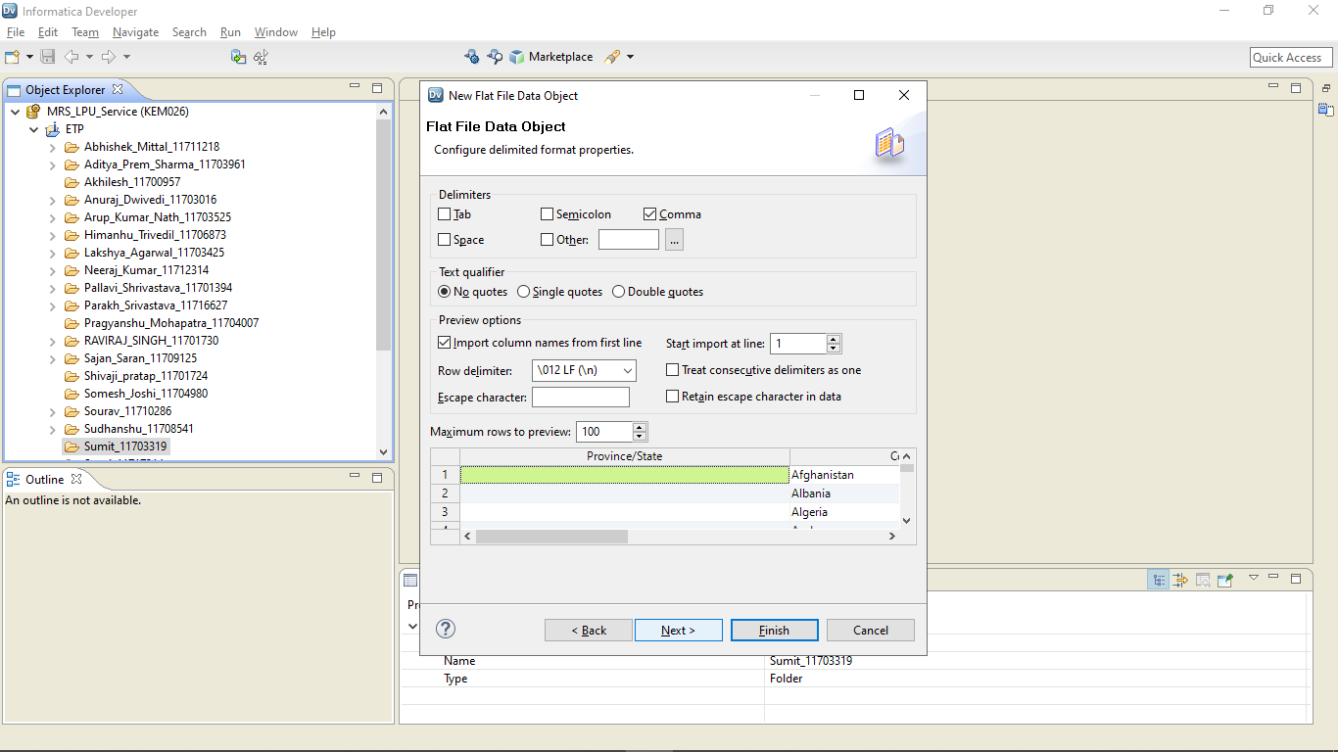

Step 4: - Click on advance and change the source file directory to C:\Informatica\10.1.1\server\Infa_shared\SrcFiles\

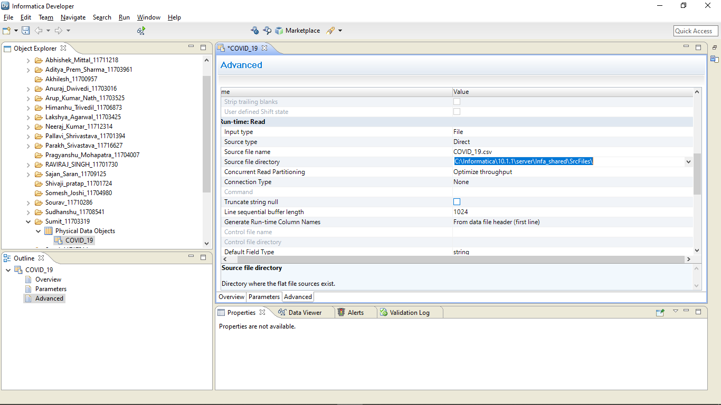

Step 4: - Select Data Viewer and run it.

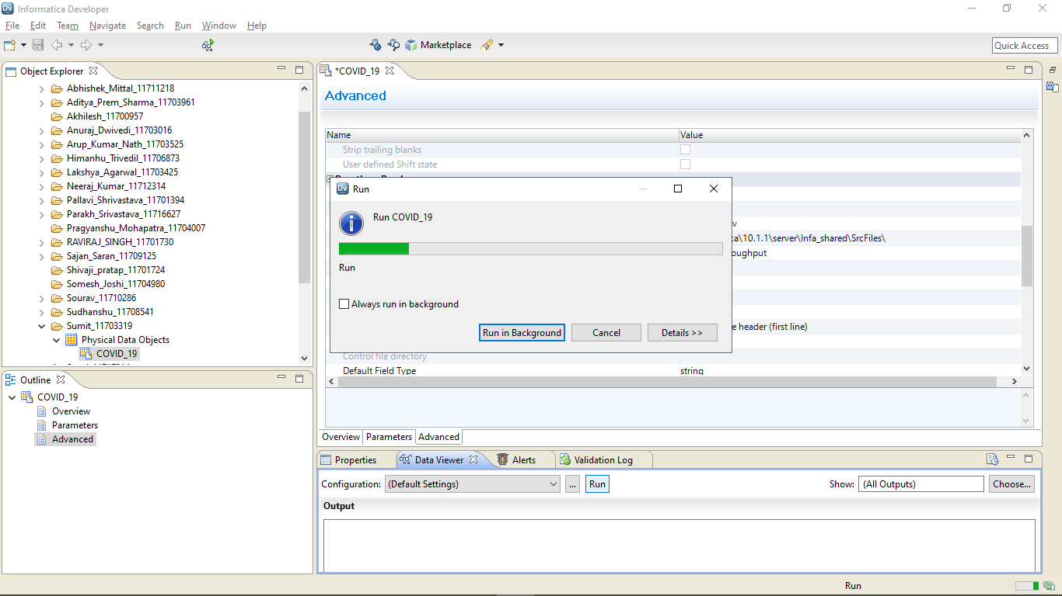

Step 5: - Go to the folder just created and right click then create a mapping.

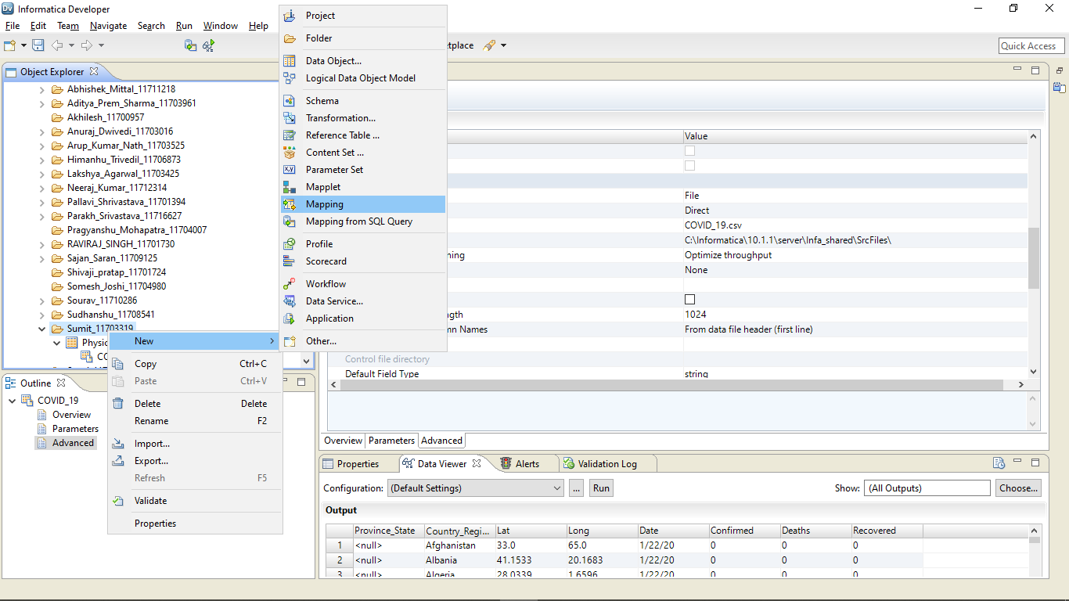

Step 6: - Import the COVID 19 File by drag and drop. First import in read mode then import in write mode. Double click on Filter and Aggregate from palette.

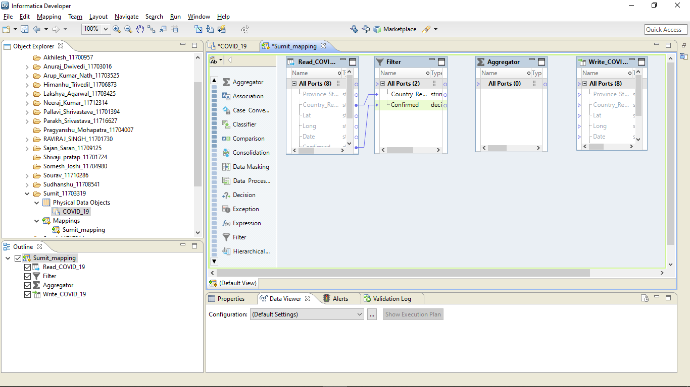

Step 7: - Drag Country_Region and Confirmed to Filter. Select Country_Region in Filter then click properties then filter then write the formula for filtering and validate it.

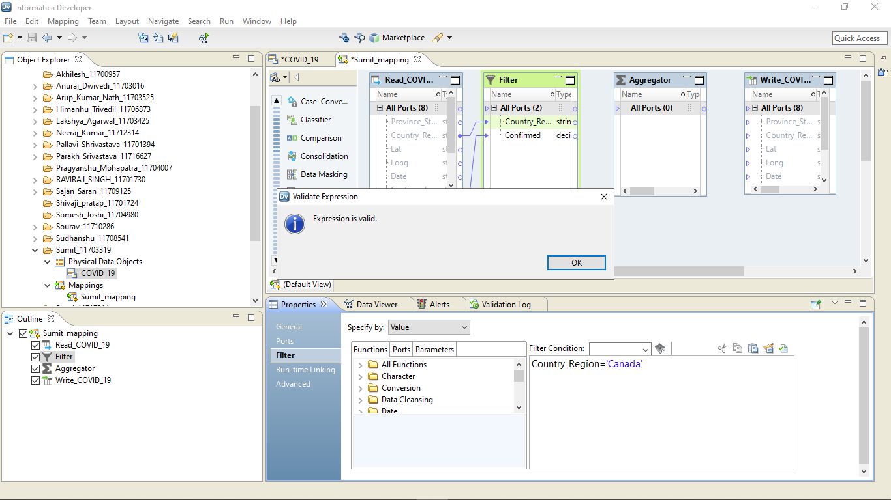

Step 8: - Connect Country_Region and Confirmed from Filter to aggregate. Click on Confirmed then go to its properties then ports option. Uncheck the output option of Confirmed.

Step 9: - Create a Total_Comfirmed with type decimal and uncheck the input option. Write SUM(Confirmed) in command area and validate it.

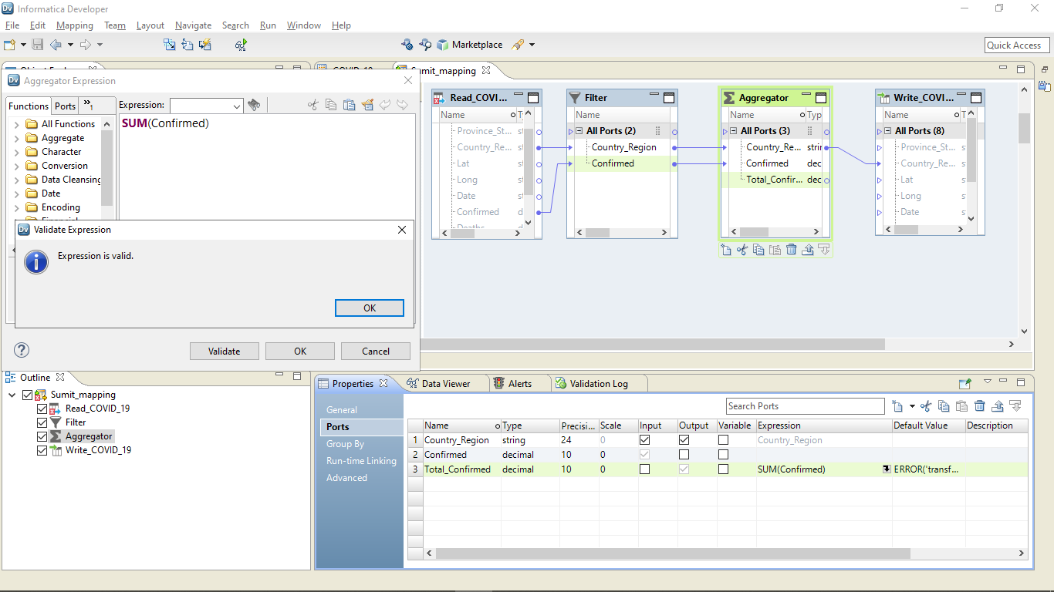

Step 10: - Connect the Country_Region from Aggregation to the target file. Select Aggregator, go to Data viewer and run it.

Output: -

|  |  |
| --- | --- |
| **Country_Region** | **Total_Comfirmed** |
| Canada | 114276 |

